Deleting a Document using cURL Utility

You can delete a document in CouchDB by sending an HTTP request to the server using DELETE method through cURL utility. Following is the syntax to delete a document.

curl -X DELETE http : // 127.0.0.1:5984 / database name/database id?_rev id

Using **−X,** we can specify a custom request method of HTTP we are using, while communicating with the HTTP server. In this case, we are using Delete method. To delete a database /database_name/database_id/ is not enough. You have to pass the recent revision id through the url. To mention attributes of any data structure **"?"** is used.

Example

Suppose there is a document in database named **my_database** with document id 001. To delete this document, you have to get the rev id of the document. Get the document data as shown below.

$ curl -X GET http://127.0.0.1:5984/my_database/001

{

" _id " : " 001 ",

" _rev " : " 2-04d8eac1680d237ca25b68b36b8899d3 " ,

" age " : " 23 "

}

Now specify the revision id of the document to be deleted, id of the document, and database name the document belongs to, as shown below −

$ curl -X DELETE http://127.0.0.1:5984/my_database/001?rev=1-

3fcc78daac7a90803f0a5e383f4f1e1e

{"ok":true,"id":"001","rev":"2-3a561d56de1ce3305d693bd15630bf96"}

Verification

To verify whether the document is deleted, try to fetch the document by using the **GET** method. Since you are fetching a deleted document, this will give you an error message as shown below −

$ curl -X GET http://127.0.0.1:5984/my_database/001

{"error":"not_found","reason":"deleted"}

Deleting a Document using Futon

First of all, verify the documents in the database. Following is the snapshot of the database named **tutorials_point**.

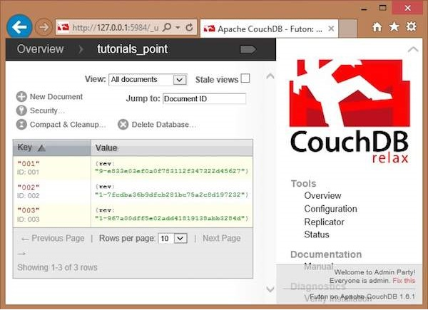

Here you can observe, the database consists of three documents. To delete any of the documents say **003,** do the following −

* Click on the document, you will get a page showing the contents of selected document in the form of field-value pairs.
* This page also contains four options namely **Save Document, Add Field, Upload Attachment, Delete Document.**
* Click on **Delete Document** option.
* You will get a dialog box saying **"Are you sure you want to delete this document?"** Click on delete, to delete the document.

